**PIZZA_SALES SQL QUERIES**

**KPI’S**

1. **Total Revenue:**



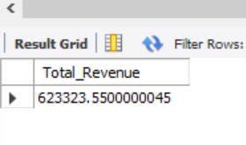

1. **Average Order Value:**



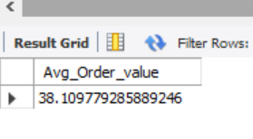

1. **Total Pizza Sold**



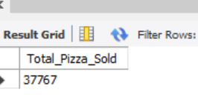

1. **Total Pizza orders**



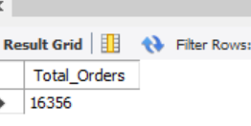

1. **AVG PIZZAS PER ORDER**

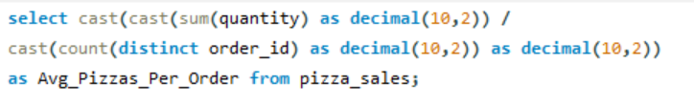

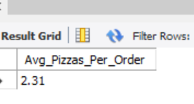

1. **DAILY TREND FOR ORDERS**



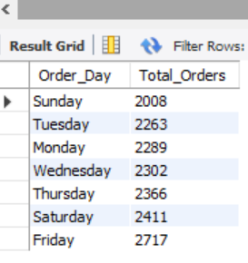

1. **MONTHLY TREND FOR ORDERS**



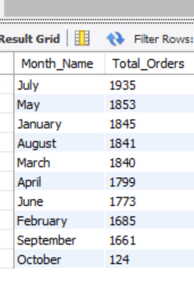

1. **PERCENTAGE OF SALES BY PIZZA CATEGORY**



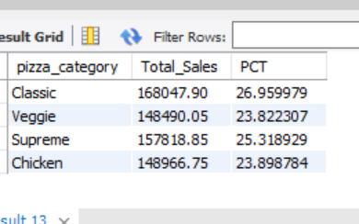

1. **PERCENTAGE OF SALES BY PIZZA SIZE**

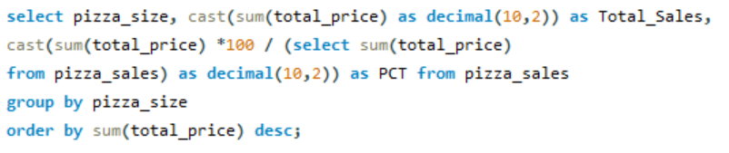

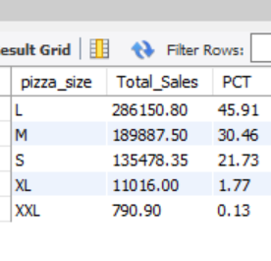

1. **TOTAL PIZZA SOLD BY PIZZA CATEGORY**

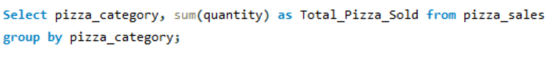

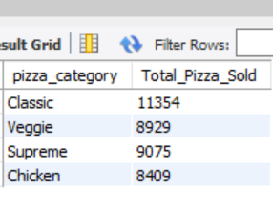

1. **BEST SELLERS PIZZAS BY REVENUE**

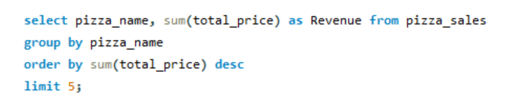

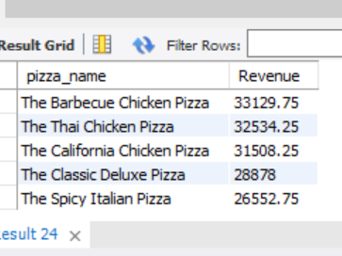

1. **Bottom 5 PIZZAS BY REVENUE**

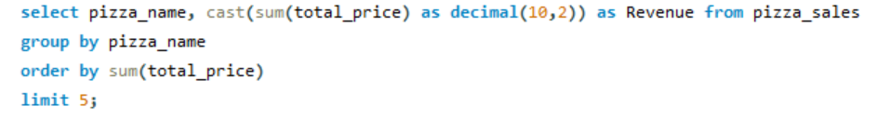

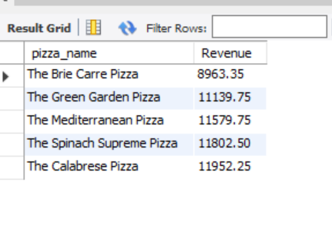

1. **BEST SELLERS PIZZAS BY Quantity**

